Bug Report Summary

On adding the M sized dress (product) to cart , S sized product is added in the cart

Project – Automation Assessment

Issue Type – Bug

Business Severity – High

Version (Test) – V1

Description :

User select the size checkbox as ‘M’ the results displayed and user tries to add the product to the cart and it is added.

When the product is viewed in the cart – S sized product is added

Steps to reproduce :

Login to <http://automationpractice.multiformis.com/>

Select Women - > form available filter in side panel Select M Size check box

Go to the ‘in stock’ product in result table view and hover on it

Add the product to the cart

Go to cart

View the product that is added in the cart

Go the description of the product in cart view   
The size should be displayed

Expected Result - > Size – M

Actual Result - > Size – S

Suggestion : On result table view when ‘add to cart’ is clicked the size suggestion could be placed so user can select the required size to be added to the cart  
  
  
Attachment

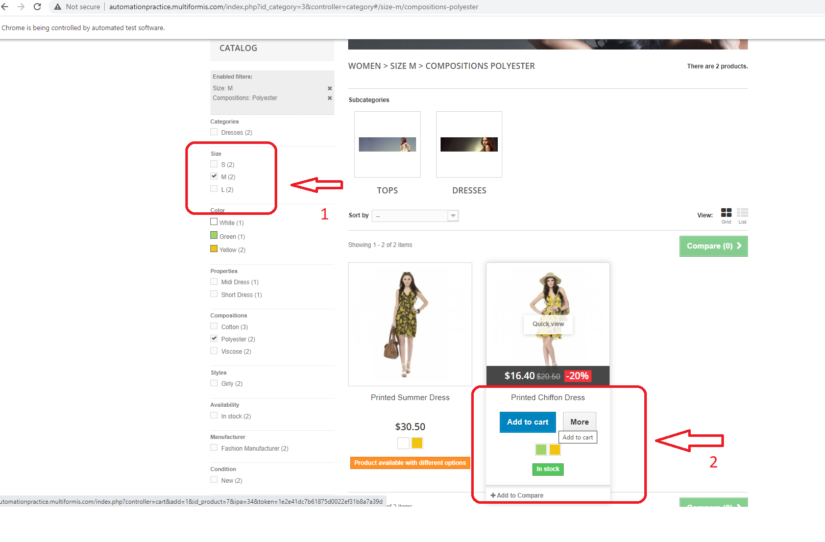

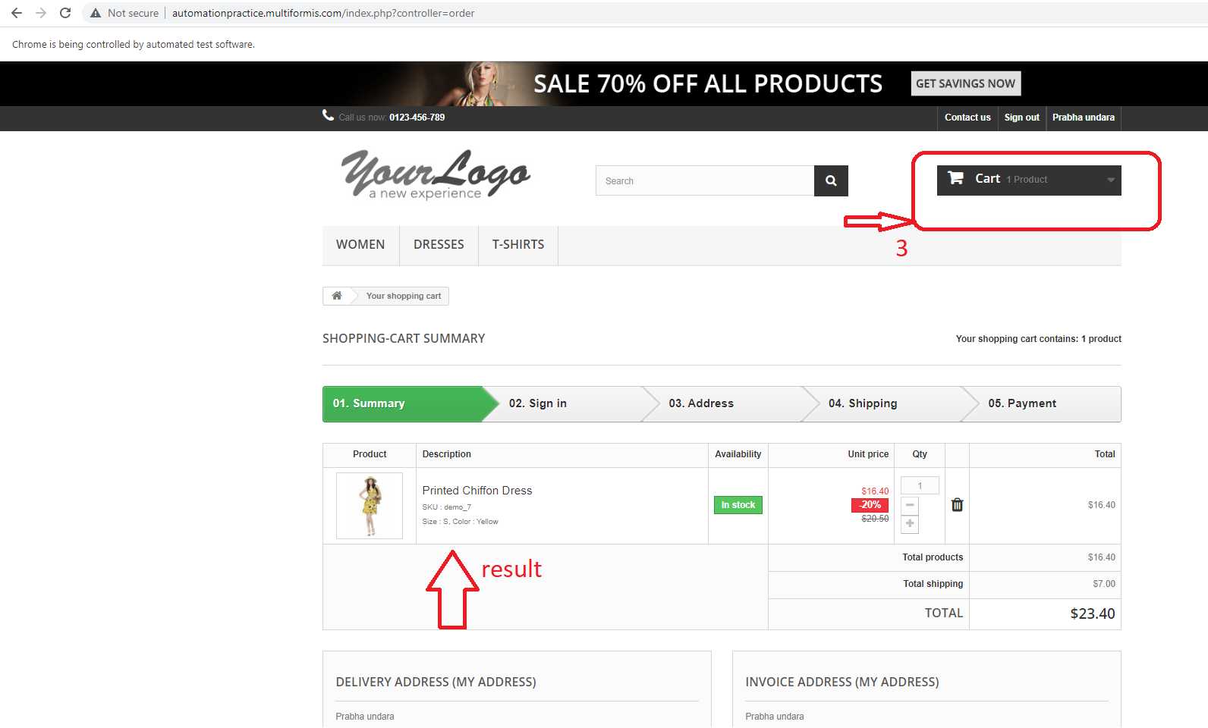

Assignee : Developer name

Label : Sprint Name/Number

Reporter : Prabha Sundaramoorthy

Date : 02/06/22